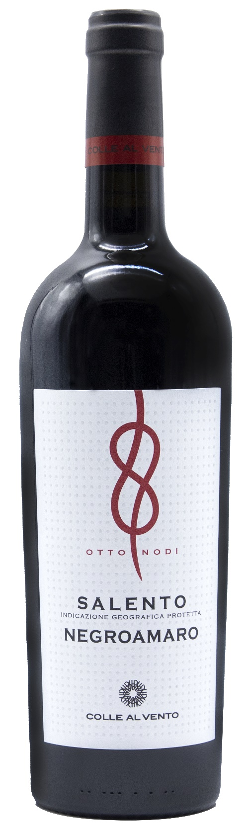
NEGROAMARO SALENTO IGP – OTTO NODI

Grape: Negroamaro 100%
Alc. Vol.%: 13
Vintage: 2024
Residual sugar g/l: 9,0
Total acidity g/l: 5,7
Region: Apulia
Production zone: Southern Apulia, Salento Area
Capacity: 750ml

CHARACTERISTICS

Vinification: After a soft pressure and the separation of grape-stalk, 10-14 days of classic peel maceration at a controlled temperature
Aging: In steel tanks
Yield per ha: 14000kg
Colour: Intense red with purple reflections
Bouquet: Harmonious with pleasant aroma of berries
Flavour: Full-bodied with noble tannins

SERVING SUGGESTIONS

Best enjoyed with savoury pasta and poultry.
Serving temperature 16-18 °C
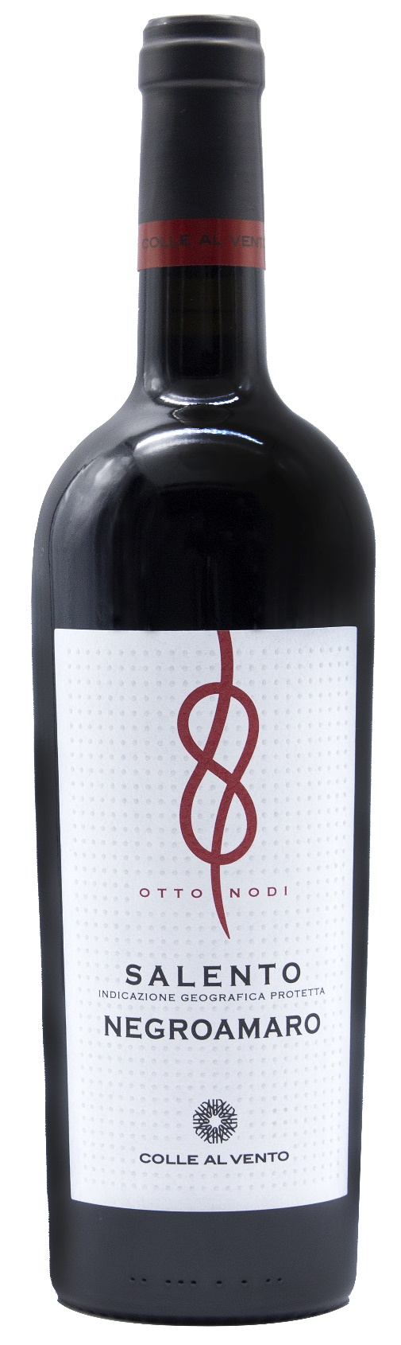
TECHNICAL INFORMATION / PALLETIZING

Size 750ml:
Article Nr. V03010A
GTIN-13 bottle 8017868001669
GTIN-13 carton 8017868001676
Closure Cork
Bottles / carton 6 bottles
Pallet size 80x120cm
Cartons/layer 21
Cartons/pallet 105
Kg/carton 7,8
Kg/pallet 840

Contains sulphites
GMO Free
Revisione 01. 14.05.2026

